Confirmation Homework Assignment 24
The Sacrament of Baptism, Part 2
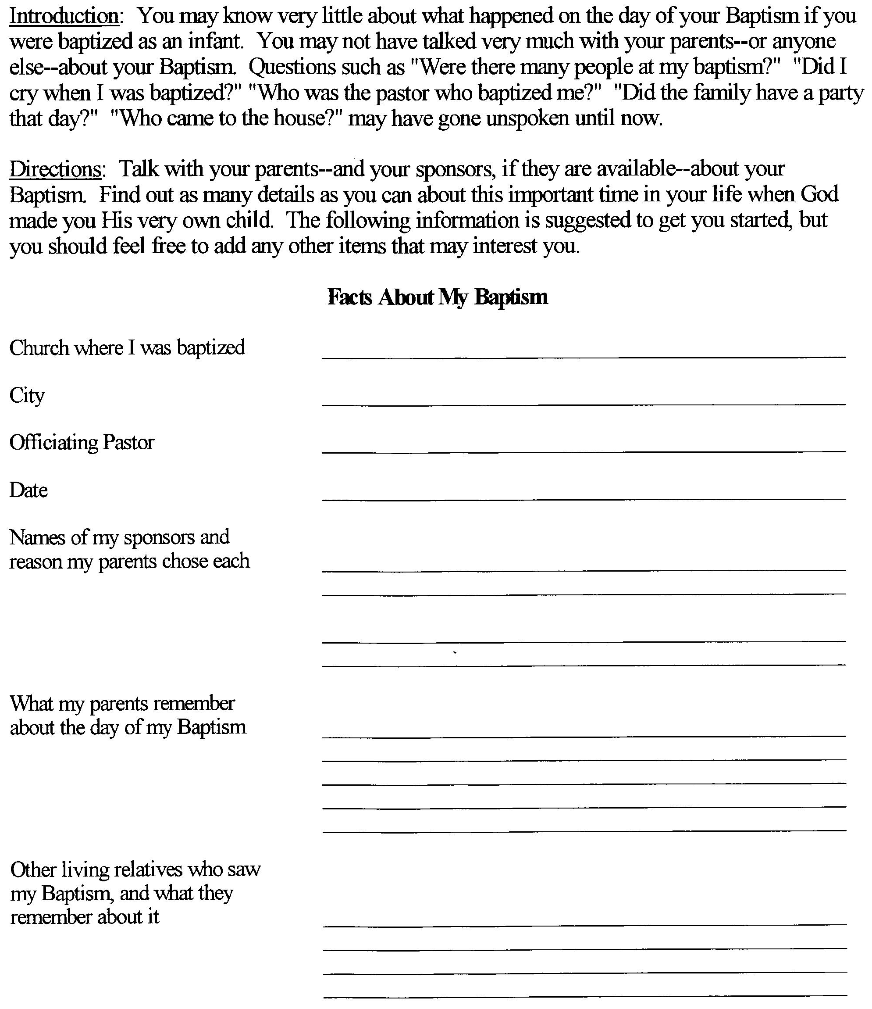
Memory Work:
Titus 3:5-8: [God] saved us, through the washing of rebirth and renewal by the Holy Spirit, whom He poured out on us generously through Jesus Christ our Savior, so that, having been justified by His grace, we might become heirs having the hope of eternal life. This is a trustworthy saying.

