Confirmation Class Syllabus: 2022-23
Instructor: Pastor Dan Larsen
Cell: (507) 430-9196 (Call or text)
Email: LARSENDC@gmail.com
E-mail: Pastor@BethanyWabasso.org or Pastor@ZionSpringfieldMN.org

Introduction: [See also: Silly Bus]
Welcome to confirmation class! We are here because it's not enough just to say, "I'm a Christian!" You also need to understand what it means to be a Christian. Through this program, it is my prayer that you will learn what we believe, teach, and confess so that you can join your fellow believers in the Sacrament of the Altar.
Our church’s confirmation program takes three years. The first two years are spent learning the narrative of Scripture (1 year) and the Lutheran Confessions (1 year). Once students have established this foundation, they will proceed to the final year of our program: Apologetics, or defending the faith. This year we will be learning the narrative of Scripture, covering the whole history of the Bible from Genesis to Revelation and discovering how it’s all about Jesus.
Grading:
Grades are broken down into five main categories: Sermon summaries, homework/exams, memory quizzes, and class participation. Students will receive an A for grades 90-100%, a B for 80-89%, a C for 70-79%, a D for a 60-69%, and an F for 59% and below. An overall grade of 'C' or better is necessary to be confirmed.
Sermon Summaries (20%): When students attend church, they should also write a brief reflection on the sermon for that day. Pre-printed papers (with the heading “Sermon Notes”) to guide that reflection are available to be used; they are located on the table under the TV in the fellowship hall. Sermon summaries are also how I confirm church attendance.
Homework (40%): Students will take home a worksheet or other assignment to be completed and turned in by the next week. Late submissions will be accepted at a 10% penalty for up to one month after they are due.
Memory Quizzes (30%): Since knowledge of God's Word is key for the life of every Christian, students are expected to memorize passages from Scripture and the Lutheran Confessions to be recited at the start of the following class meeting.
Class participation (10%): This grade is very easy to earn: just come to class and participate! Pay attention, answer questions, write in your workbook where appropriate, and just help me help you to learn.
Notes for parents:
While various circumstances may prevent your family from attending worship services every week, students are expected to attend at least 18 church services in a school year, which can include Sunday morning services as well as special midweek services during Advent and Lent. If your student fails to meet this bare minimum, I will need to meet with your family to discuss church attendance. Failure to attend worship may result in dismissal from the confirmation program.
It will be especially useful to review memory assignments with your students on a daily basis, as this will help them to remember God's Word not only for the in-class quiz, but also over the long term.
Finally, thank you very much for entrusting the religious instruction of your child to our church. If you have any questions or concerns, or if you would just like to talk with me, my contact info is in the heading of this syllabus. God's blessings to you!
In Christ,

Pastor Daniel Larsen
Pastor, St. Paul’s Lutheran Church
Course Schedule
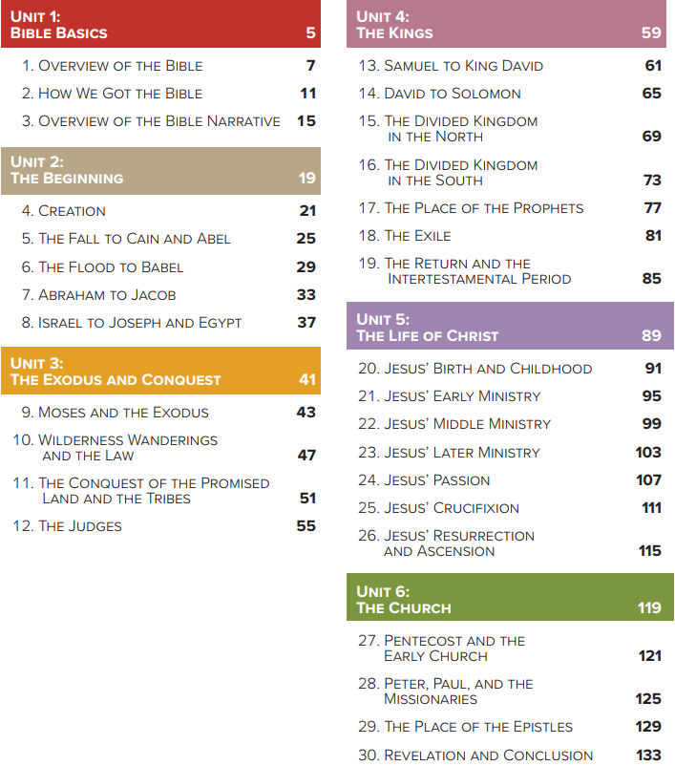
Classes will be held Wednesdays after school, 3:15-4:30, excluding MEA week (10/19), Thanksgiving week (11/23), Christmas break (12/28), and Holy Week (4/5). For weather-related cancelations, we will follow the decisions of Henning Public School—if they cancel all after-school activities, confirmation is also canceled. I will communicate all class-related information via text message.
Class sessions will also be video recorded and posted to our church web site before the weekend along with downloadable versions of homework and memory quizzes (stpaulhenning.net/confirmation.html). Make-up memory quizzes must be proctored and signed by a parent. Homework can be completed electronically and emailed to me or printed and turned in next class period. Under normal circumstances, make-up memory quizzes and homework assignments will not be accepted over 1 month beyond their due date.

